Clue Rules & and General Info

V2.5 6/1/20

**Related to CSCI306 Software Engineering version of game:**

* This game will be played by 1 human and 5 computer players. Human will move first.
* People, weapons, rooms and board layout will all be read from configuration files.
* The rooms, people and weapons do not need to match the original Clue game (have fun!)
* The board layout must have 9 rooms, and you should include a "closet" in the middle of the board for players to move around.
* A few of your rooms should not be simple rectangles.
* Two sets of two rooms should be designated secret passage rooms where the rooms are connected to each other by a secret passage (in the original Clue, these were opposite corners to allow quick passage across the board).
* The deck of cards will include 6 people, 6 weapons and the 9 rooms.

**Clue Board (original, you are free to design your own)**

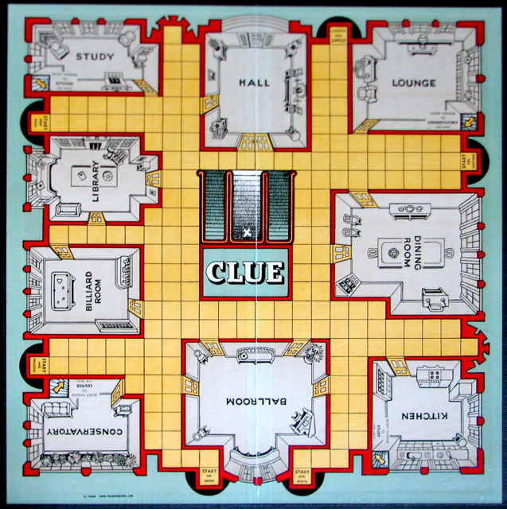

**Related to game play:**

* Object of Game
  + Is to discover who, where and with what was the murder accomplished. This is different for each game and is established by randomly drawing one card of each type from the deck and putting it in the solution.
* Setup
  + Each player has a starting position on the board.
  + Each type of card (room, weapon, person) is separately shuffled and one of each are removed. These three cards are the solution for the game.
  + The remaining cards are shuffled together and dealt to each player (3 cards per player)
* Turns
  + Players take turns, starting with the human player.
  + In a turn the following sequence happens:
    - The player may make an accusation
    - The player rolls the dice and moves.
    - If the player is in a room, the player makes a suggestion.
* Player movement
  + Players may move up, down, left and right but not diagonally.
  + After the human player rolls the die, the program will highlight all possible target locations.
  + Targets are all the possible grid squares that are on a path that has *exactly* that number of steps. A square may not be moved through or reentered more than once in a move (e.g., I can't move from (0,0) to (1,0) and then back to (0,0)).
  + A player may not enter or move through a walkway square if occupied by another player (you may have more than one player in a room).
  + A player may enter a room through three methods:
    - By using a doorway. In that case, the player need not have an exact count.
    - By using a secret passage. Die roll is irrelevant in this case.
    - By being called to the room by another player’s suggestion.
  + Once a player enters a room, movement is over. You cannot enter and leave a room in the same turn.
  + If a player starts their turn in a room, the player must exit the room by any door or the secret passage. A player may not choose to remain in the room UNLESS they were brought to the room by another player’s suggestion since their last move. If they choose to remain, they may make their own suggestion. A player may not reenter the same room on the same turn. must leave the room in his move.
  + If there are no possible moves, the player does not move and may not make a suggestion.
  + When a suggestion is made, the suggested player will be automatically moved to a room.
* Suggestion (Note difference between suggestion and accusation)
  + A *suggestion* is a guess of room, person and weapon. The purpose of a suggestion is to eliminate possibilities. So a player says something like "I suspect Mrs. Peacock with the knife in the library" and other players try to "disprove" that suggestion by showing a card from their hand.
  + Suggestions may only be made when a player enters a room (or they start in a room as a result of a previous players suggestion).
  + The suggested room must match the room the player is in (e.g., you can't be in the ballroom and suggest the library).
  + When a suggestion is made, the person in the suggestion is immediately moved to that room (e.g if Miss Scarlet is suggested, she is put in the room).
  + A suggestion is "disproved" if another player holds a card that matches one of the suggestions (e.g., a player might have Mrs. Peacock).
  + Disproval occurs one player at a time starting with the next sequential player.
    - First cut: All players are handled by the AI. If that player has a card that disproves the suggestion, it is shown to the person that made the suggestion. If the player has more than one card that disproves the suggestion, the player randomly picks one of the cards to show. If the player has no cards to disprove the suggestion, the player passes, and we move on to the next player to try to disprove the suggestion.
    - Better: If the player is Human, a window opens to allow the player to select which card to show. If the player is AI, the player tracks what cards have been shown to each player, and tries to show the same card if possible.
  + All players get to see if a person passes or disproves a suggestion. Only the player making the suggestion gets to see the specific disproving card (as such, other players only know that one of the three aspects of the suggestion is wrong).
  + Once a suggestion is disproven, no other players are checked to see if they also can disprove the suggestion.
  + *Strategy question: What is implied if all players pass? Does it mean the suggestion is the solution? Think about this.*
* Accusation
  + An *accusation* is made when the player thinks s/he knows the solution.
  + Accusations are made at the start of the player's turn after rolling the dice. (Note, the actual clue game says before rolling the dice, but that would require an additional button to roll the dice. The team may decide to implement this but it is not required.)
  + The player does not need to be in a room.
  + An accusation consists of a room, weapon and person.
* Winning
  + A player wins the game if their *accusation* is correct.
  + A player loses the game and their piece is removed from the board if the *accusation* is incorrect. Note, if the human loses, the game is over.

### Helpful links

* General information about Clue can be found: https://en.wikipedia.org/wiki/Cluedo
* Rules of the game: <https://www.manualslib.com/manual/65945/Parker-Brothers-Clue-Classic-Detective-Game.html#manual>
* Board layouts and other potentially helpful information: <http://www.cluedofan.com/cmerch/computer.html>
* Online version of 1992 Version of Clue
  + <https://arcadespot.com/game/clue/>
  + <https://kbhgames.com/game/clue-online>